Report web programming2

Name : Muhammad Rafi Ramadhan Kartika
Student Id : EX251436 (exchange student
table of content
vue pt 1
Vut pt2
Vue pt3

TASK
Vue part 1 ( Lesson 2-3-4)
https://github.com/FGW-IT-HCM/FGW-IT-HCM-TRANLT-FA25-COMP1842-VUE-1-MRafiRamadhanK
- Lesson 2
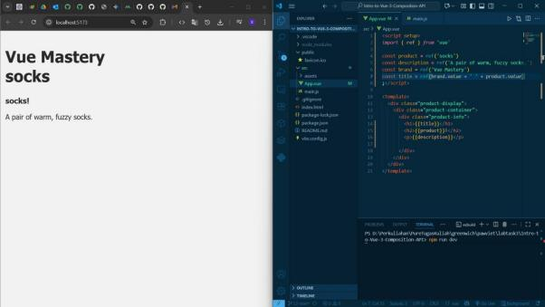

- Lesson 3
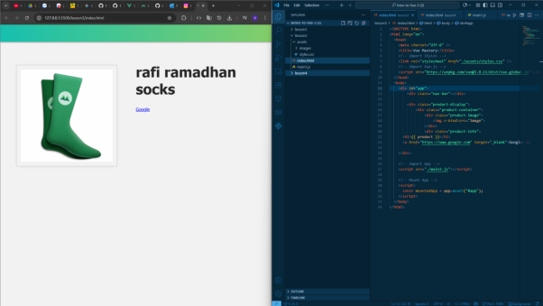

- Lesson 4
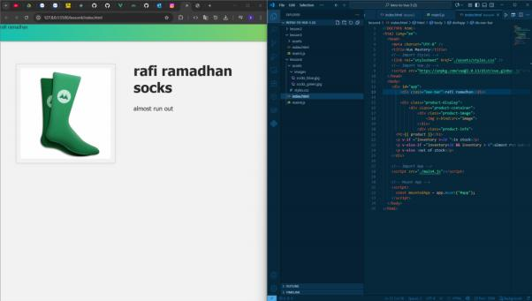

Vue Part 2 ( Lesson 5-6-7)
https://github.com/FGW-IT-HCM/FGW-IT-HCM-TRANLT-FA25-COMP1842-VUE-2-MRafiRamadhanK
- Lesson 5
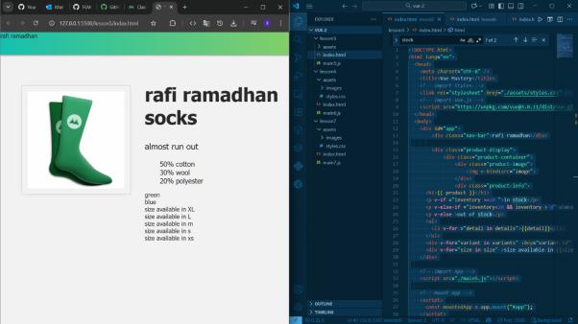
- Lesson 6
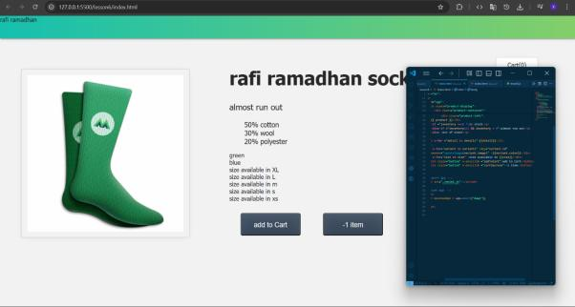

- Lesson 7
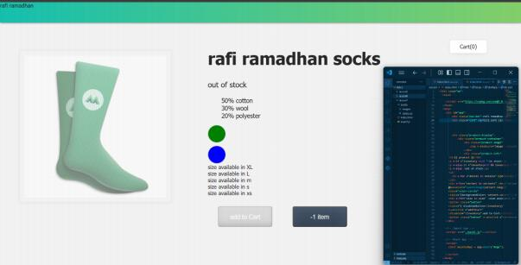
Vue part 3 ( Lesson 8-9-10)
https://github.com/FGW-IT-HCM/FGW-IT-HCM-TRANLT-FA25-COMP1842-VUE-3-MRafiRamadhanK
- Lesson 8
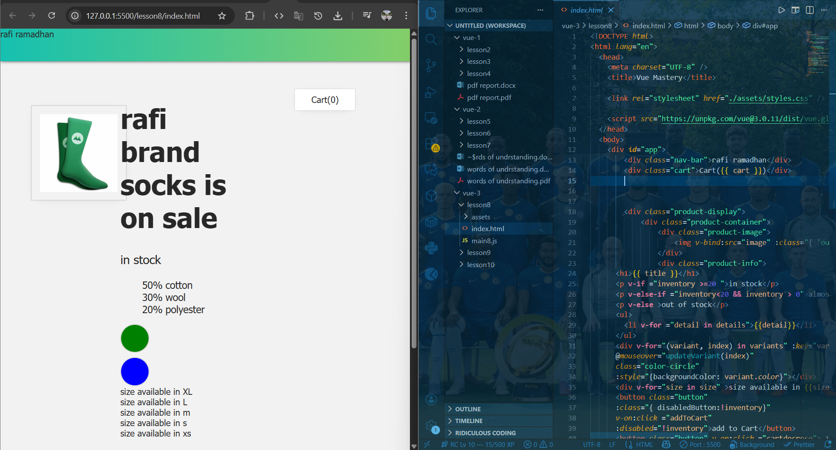

- Lesson 9
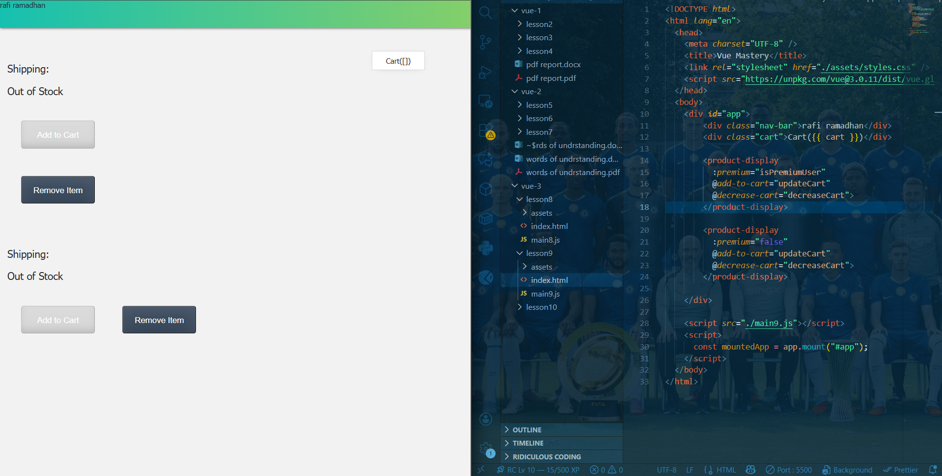

- Lesson 10
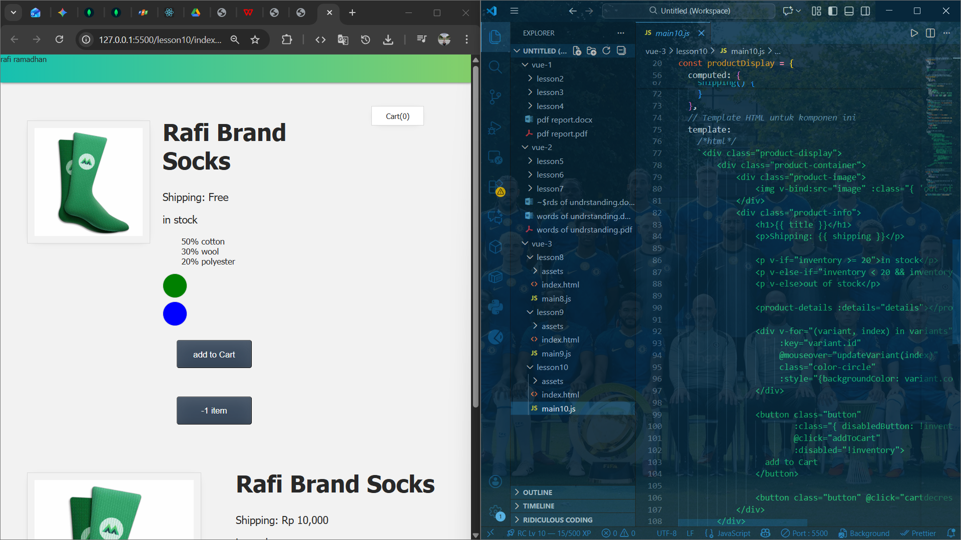

Restful-API
https://github.com/FGW-IT-HCM/rFGW-IT-HCM-TRANLT-FA25-COMP1842-RESTFUL-API-MRafiRamadhanK

Node.js
https://github.com/FGW-IT-HCM/FGW-IT-HCM-TRANLT-FA25-COMP1842-NODEJS-MRafiRamadhanK

